**Hadoop Setup on CentOS 7 and Assignment 1**

**By Waseem Shah**

I have installed and Configured Apache Hadoop as a Single Node machine (i.e. all Hadoop daemons working on one Machine. This machine will act as both client and host on a Single Node Cluster). 😊

**Required system configuration:**

Windows or Mac OS (My setup was on Windows 10)

Oracle VM VirtualBox Manager – configure with Centos 7 image. Use the below link:

For Mac and Windows users: <https://drive.google.com/file/d/1iLsagM3uI-I88qZwT4I6XggZpUlwlO_e/view>

**Note**: This Hadoop setup has 18 steps in total and it may take 5-8 hours to complete, depending on how good you are with Linux commands.

**Step 1:**

Install JDK 8 and Configure Environmental variables

Use “wget” to download .tar JDK8 file as mentioned in 2nd line of code

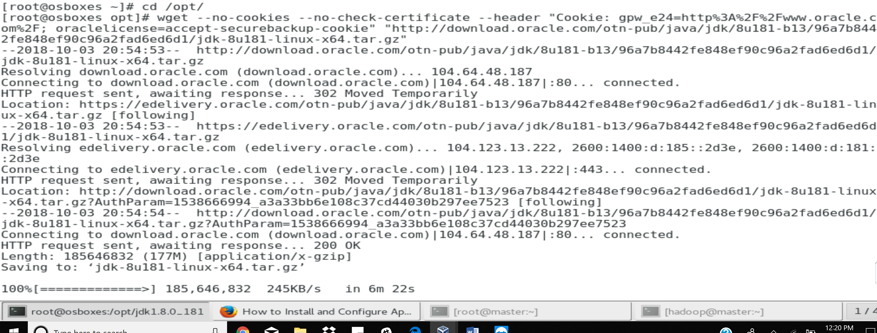

**Step 2:**

Unzip JDK 8: Unzip .tar file and Install using the commands mentioned below

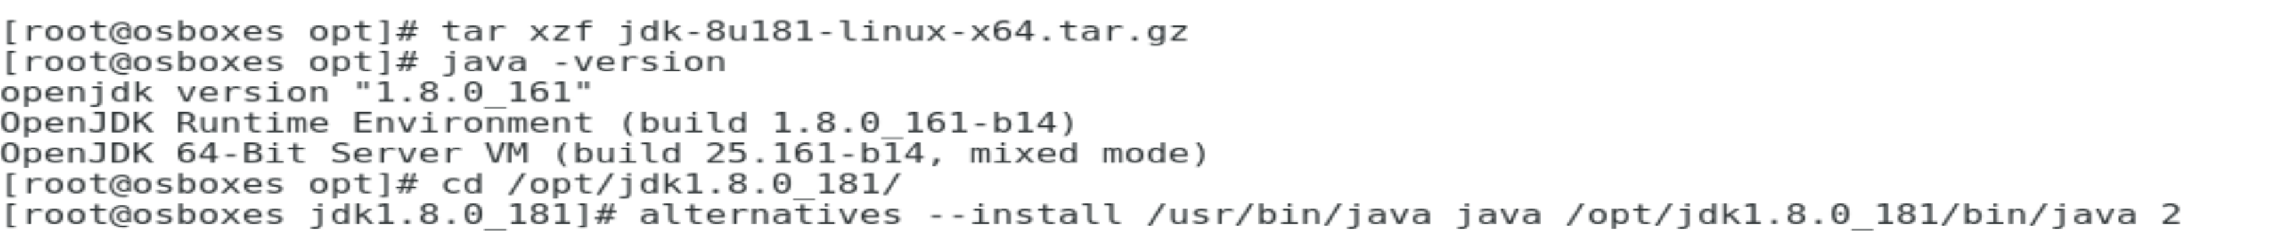

**Step 3:**

Select the desired Java version using “—config java” and make suer to install all Alternatives mentioned bleow

**Note**: This is useful when you have more then one JDK installed on your machine 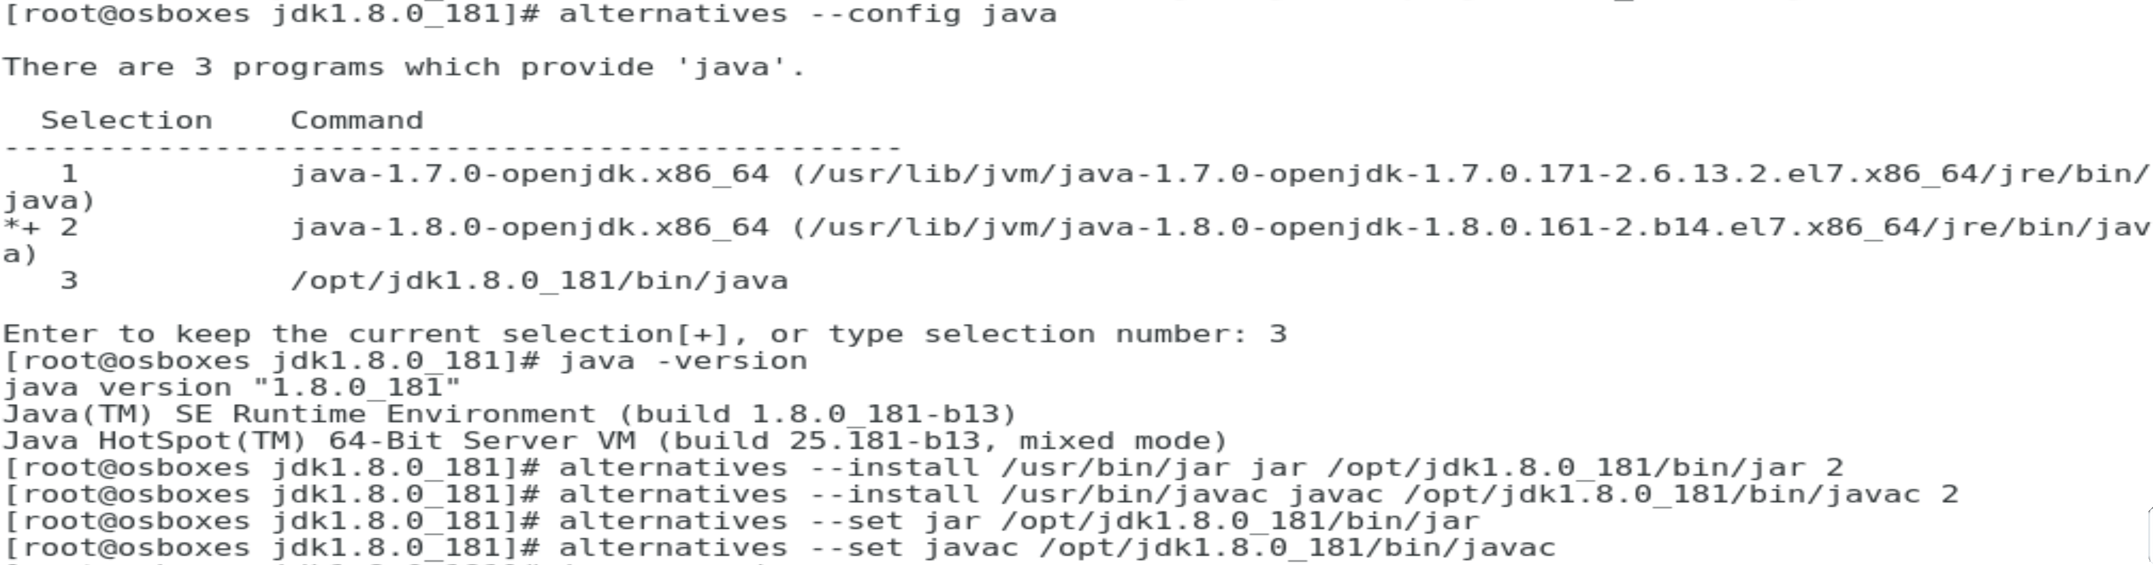

Check for Java version using “java –version”

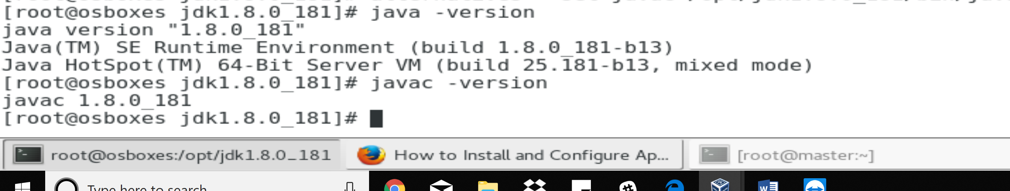

**Step 4:**

Install Hadoop framework in Centos 7: Create Hadoop for a Single node configuration.

**Note**: Create a new user “Hadoop” and set path & working environment as mentioned below.

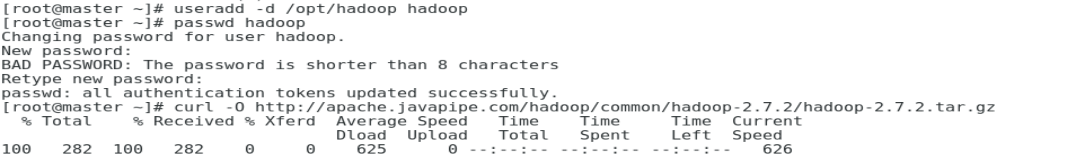

**Step 5:**

Download Hadoop 2.7.2 tar file from Apache.org using below link: use “wget” for downloading

<http://archive.apache.org/dist/hadoop/core/hadoop-2.7.2/hadoop-2.7.2.tar.gz>

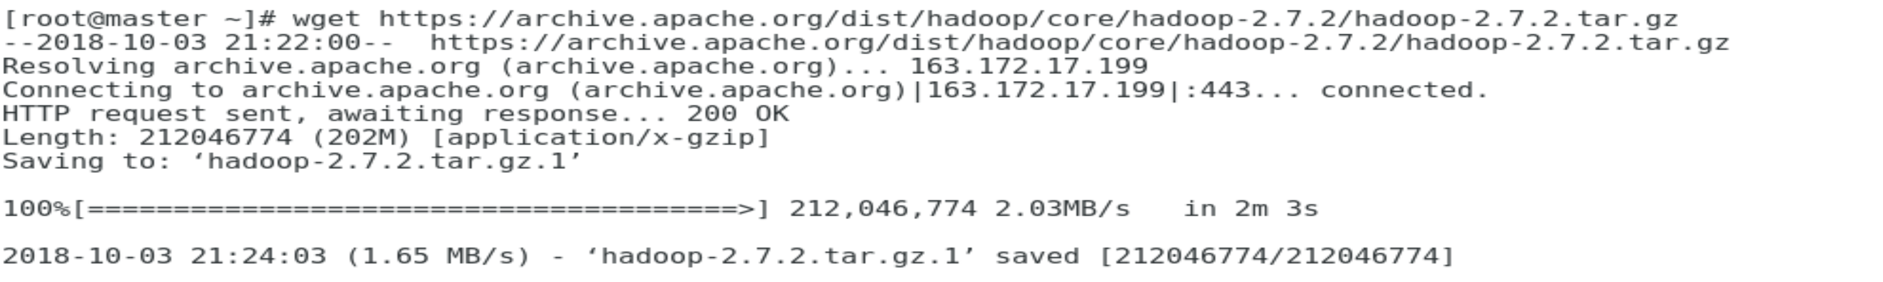

Extract Hadoop tar file and copying it to user Hadoop and assign permissions

**Note** all the commands mentioned below, use “Hadoop-2.7.2.tar.gz.1” for extraction.

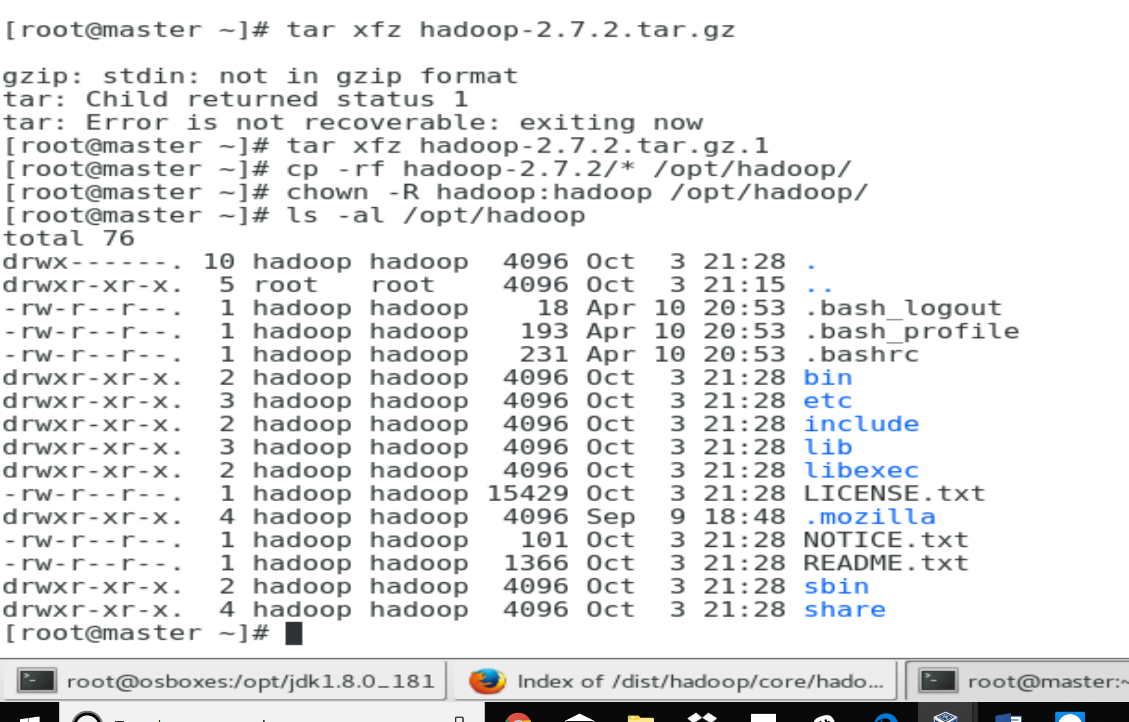

**Step 6:**

Switch to user Hadoop



Configure Hadoop for .bash profile using “vi .bash_profile”

**Note**: Append all export lines below “export Path” as mentioned below. And to do that press ‘i’ to insert and to save first, esc button then : and wq! To save & q! to exit from window. Make sure for every “vi” (Visual instrument) command use the above save and exit commands.

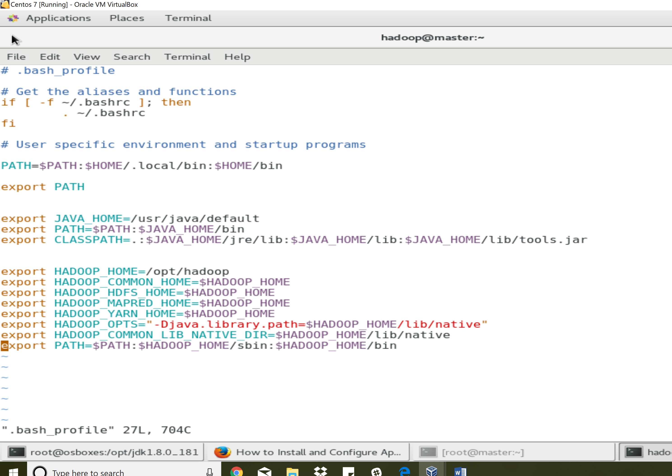

**Step 7:**

Setting SSH (Secured Shell) keygen to access Node manager and Resource Manager.

**Note**: After line insertion use “echo $HADOOP_HOME” and “echo $JAVA_HOME” to make sure its correctly setup. If not check again and proceed to next step.

The below screen shot will show you the results to be obtained.

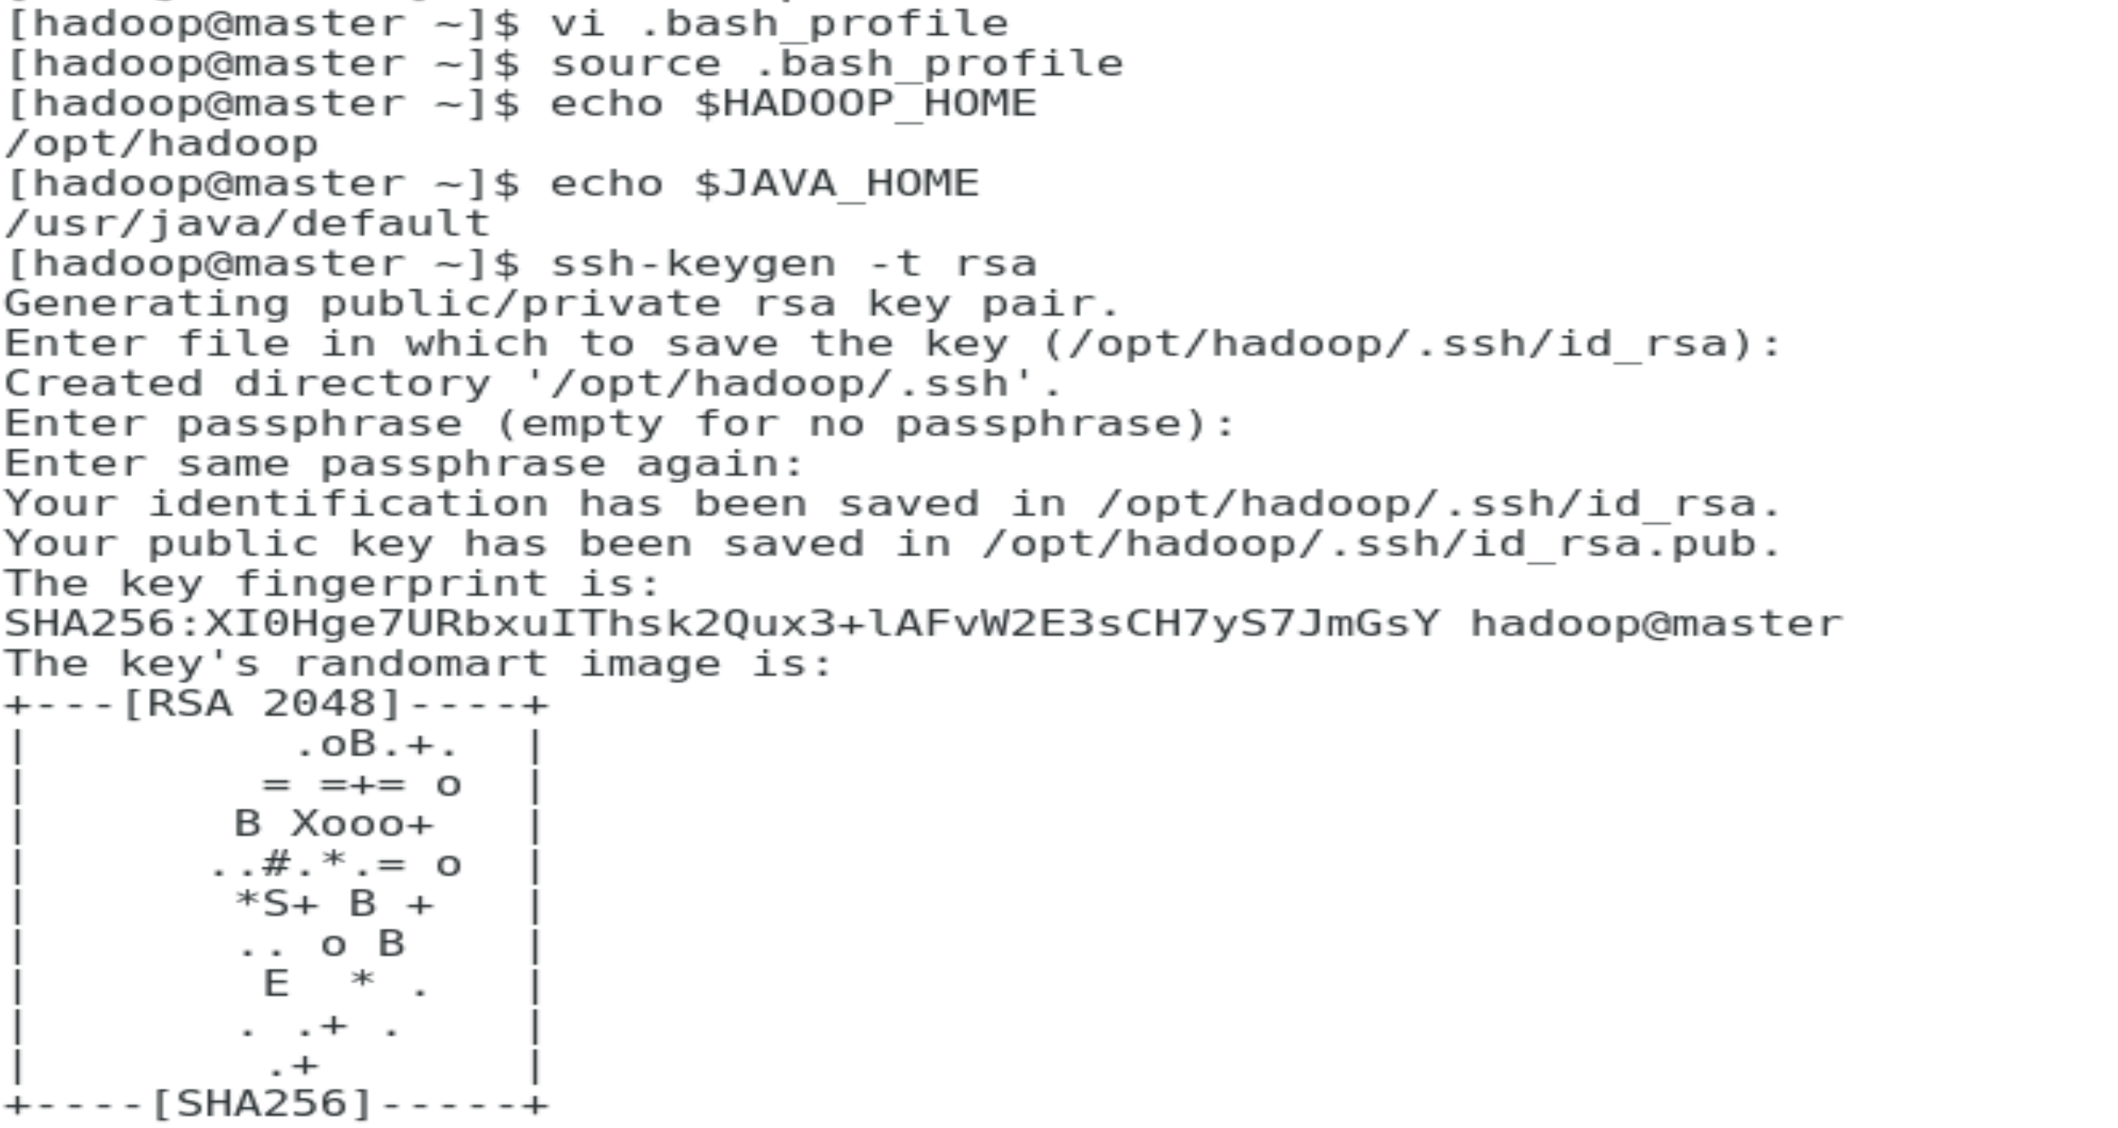

**Step 8:**

Hadoop core Setup using “vi etc/Hadoop/core-site.xml”

Open and Edit “hdfs-site.xml” Which contains Namenode path and Datanode path and replace “.dir” accordingly: 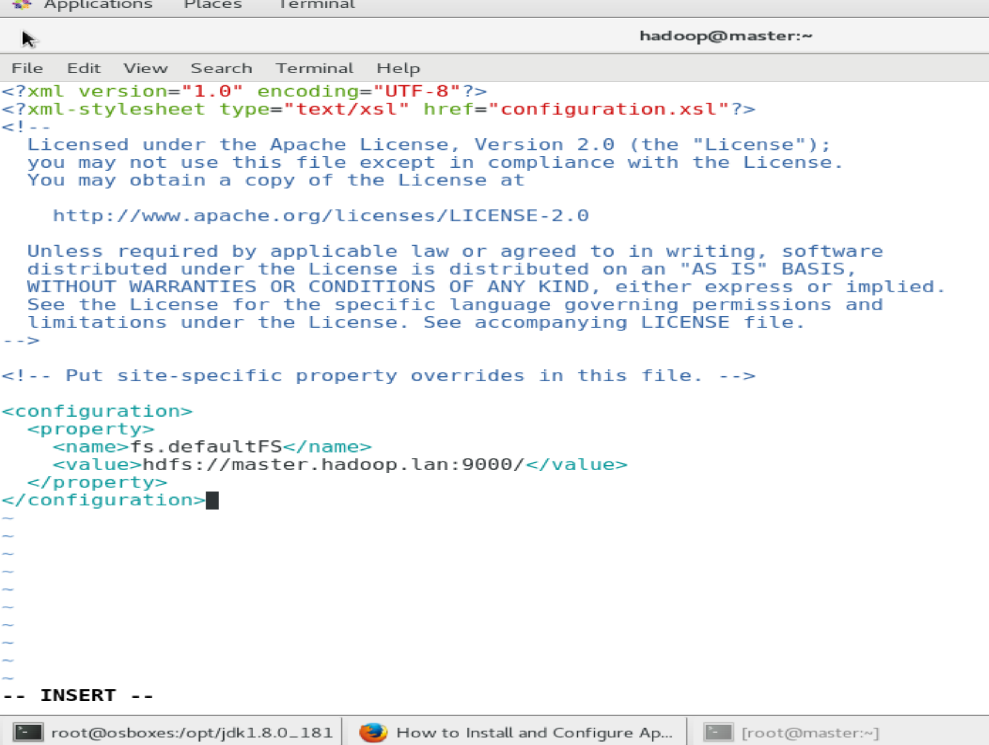

Use : “vi etc/Hadoop/hdfs-site.xml

**Note:** all line insertion should be in between two </configuration>

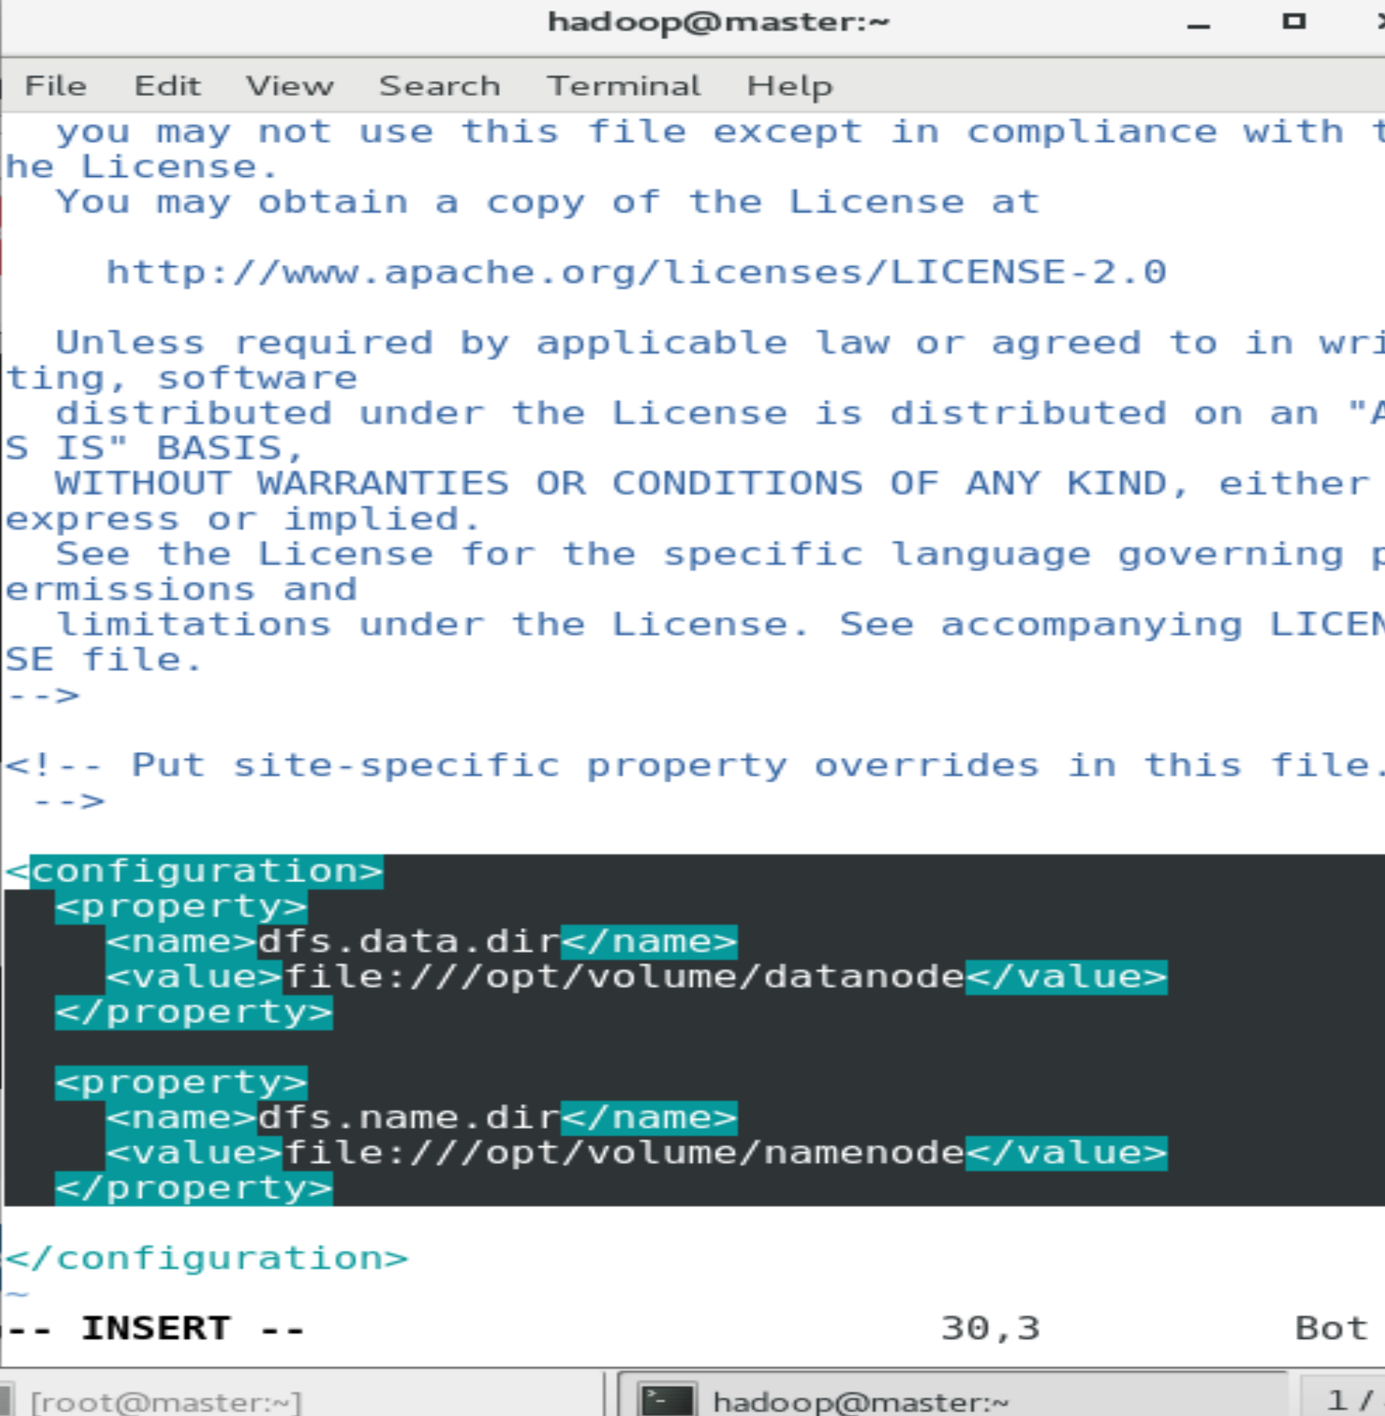

**Step 9:**

Creating Nadenode and Datanode Directories.

Switch to root user and create directories as mentioned.

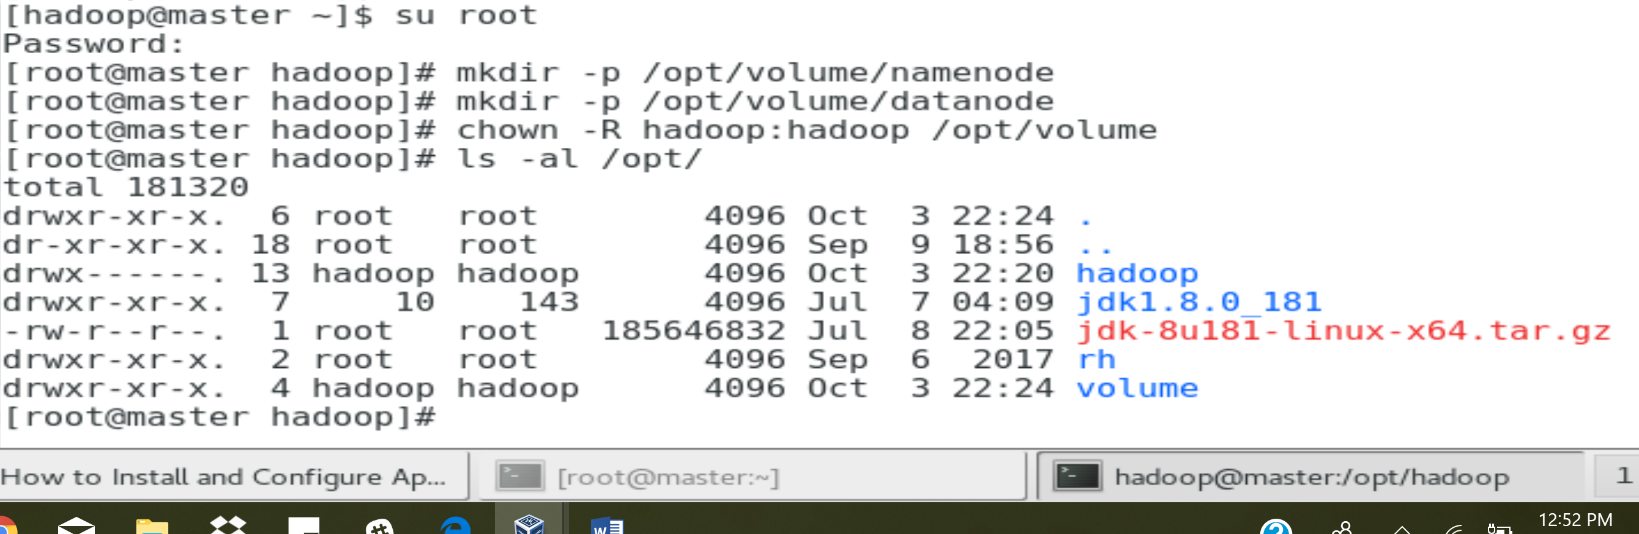

**Step 10:**

Specify Mapreduce framework using Yarn

“vi etc/hadoop/mapred-site.xml”

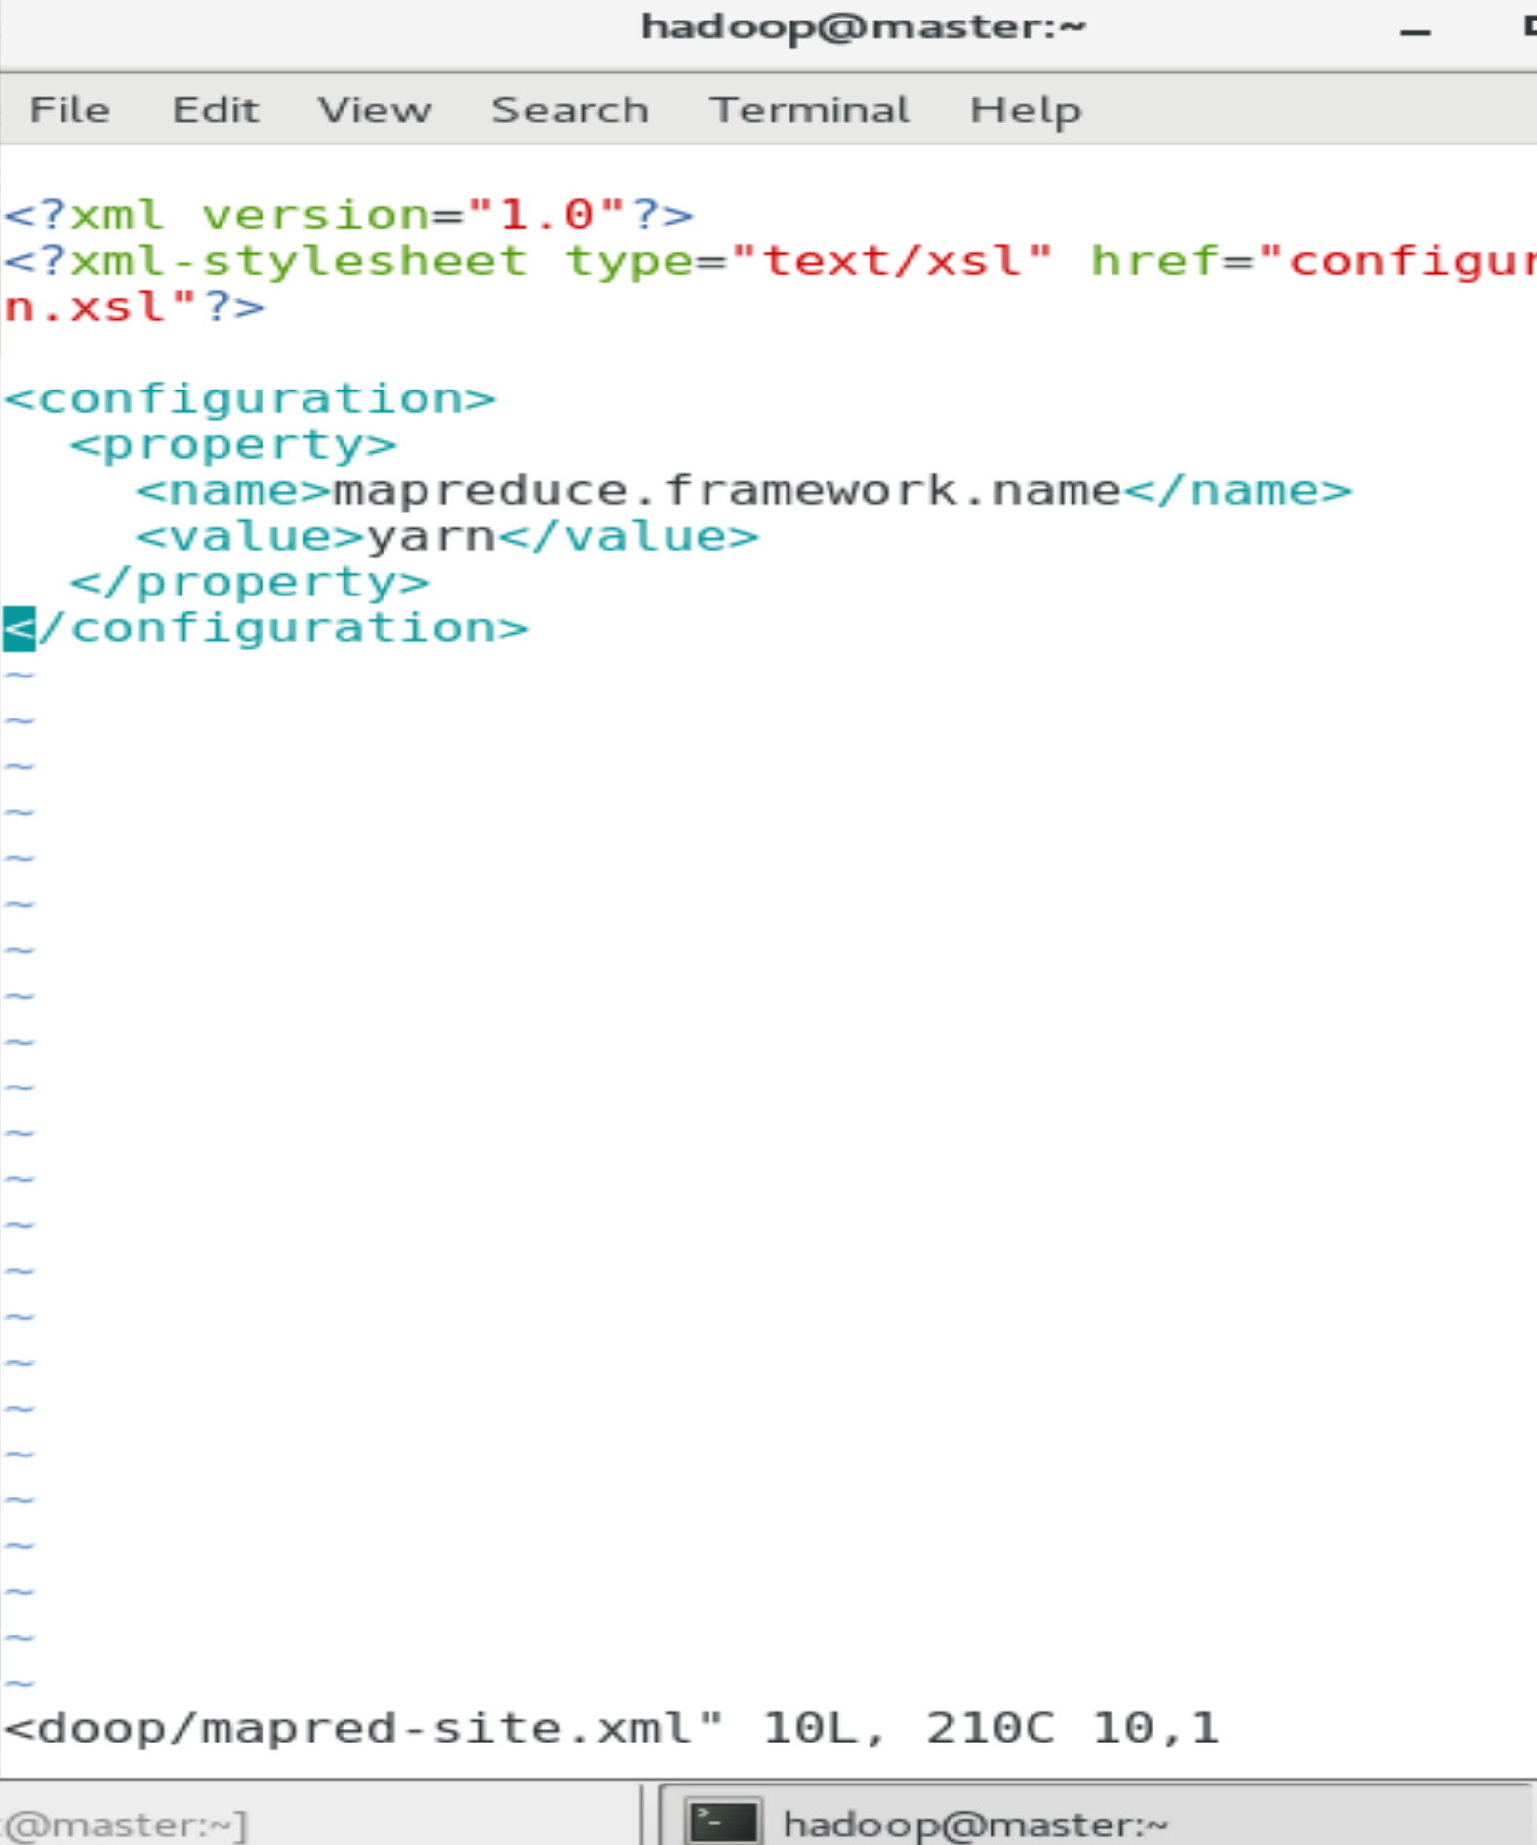

Setup Yarn using ““vi etc/hadoop/yarn-site.xml”

Here insert lines between <configuration>

**Note**: No gap between first line and first <?xml version=”1.0”?> statement.

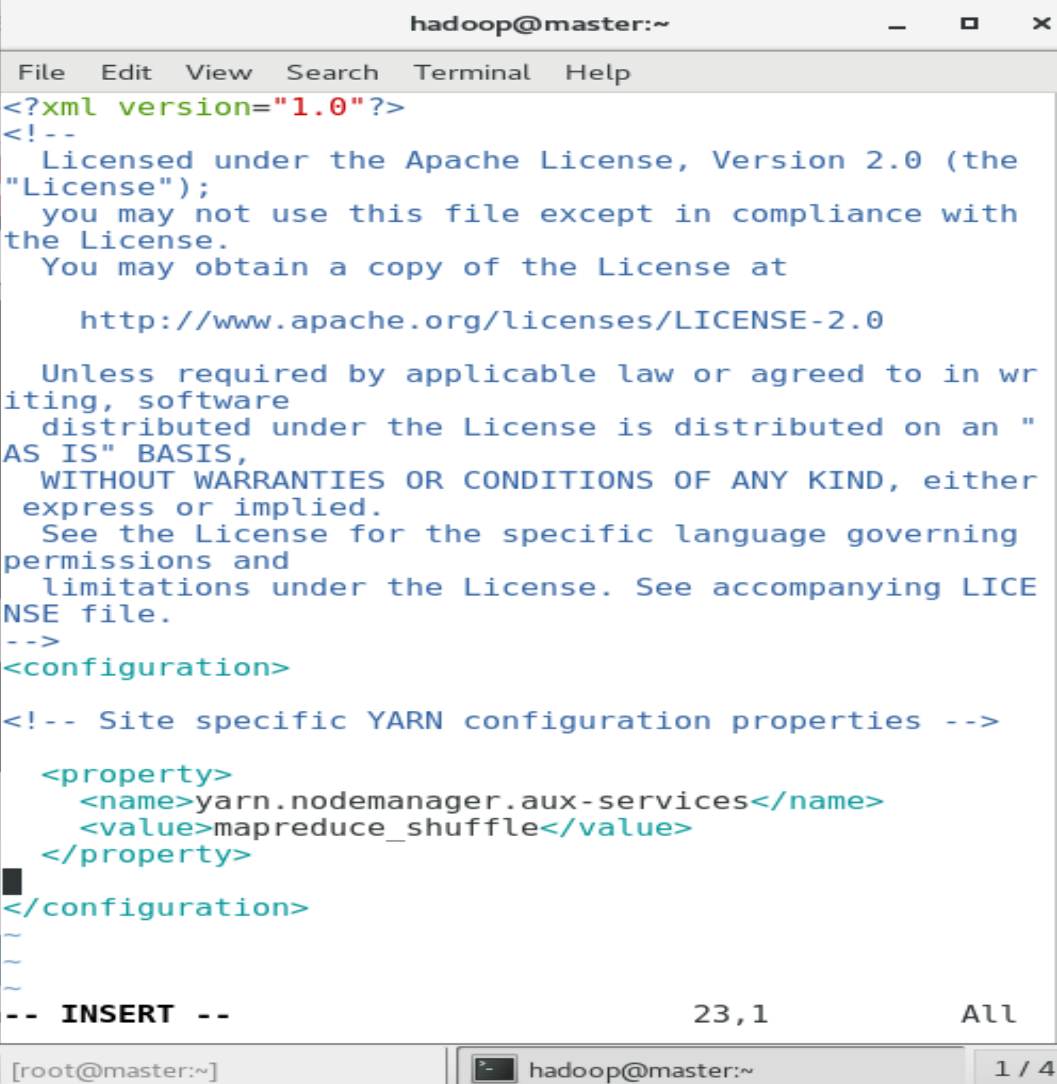

**Step 11:**

Setup Java_Home variable for Hadoop environment using “Hadoop.-env.sh” and changed it to default Java_home path.

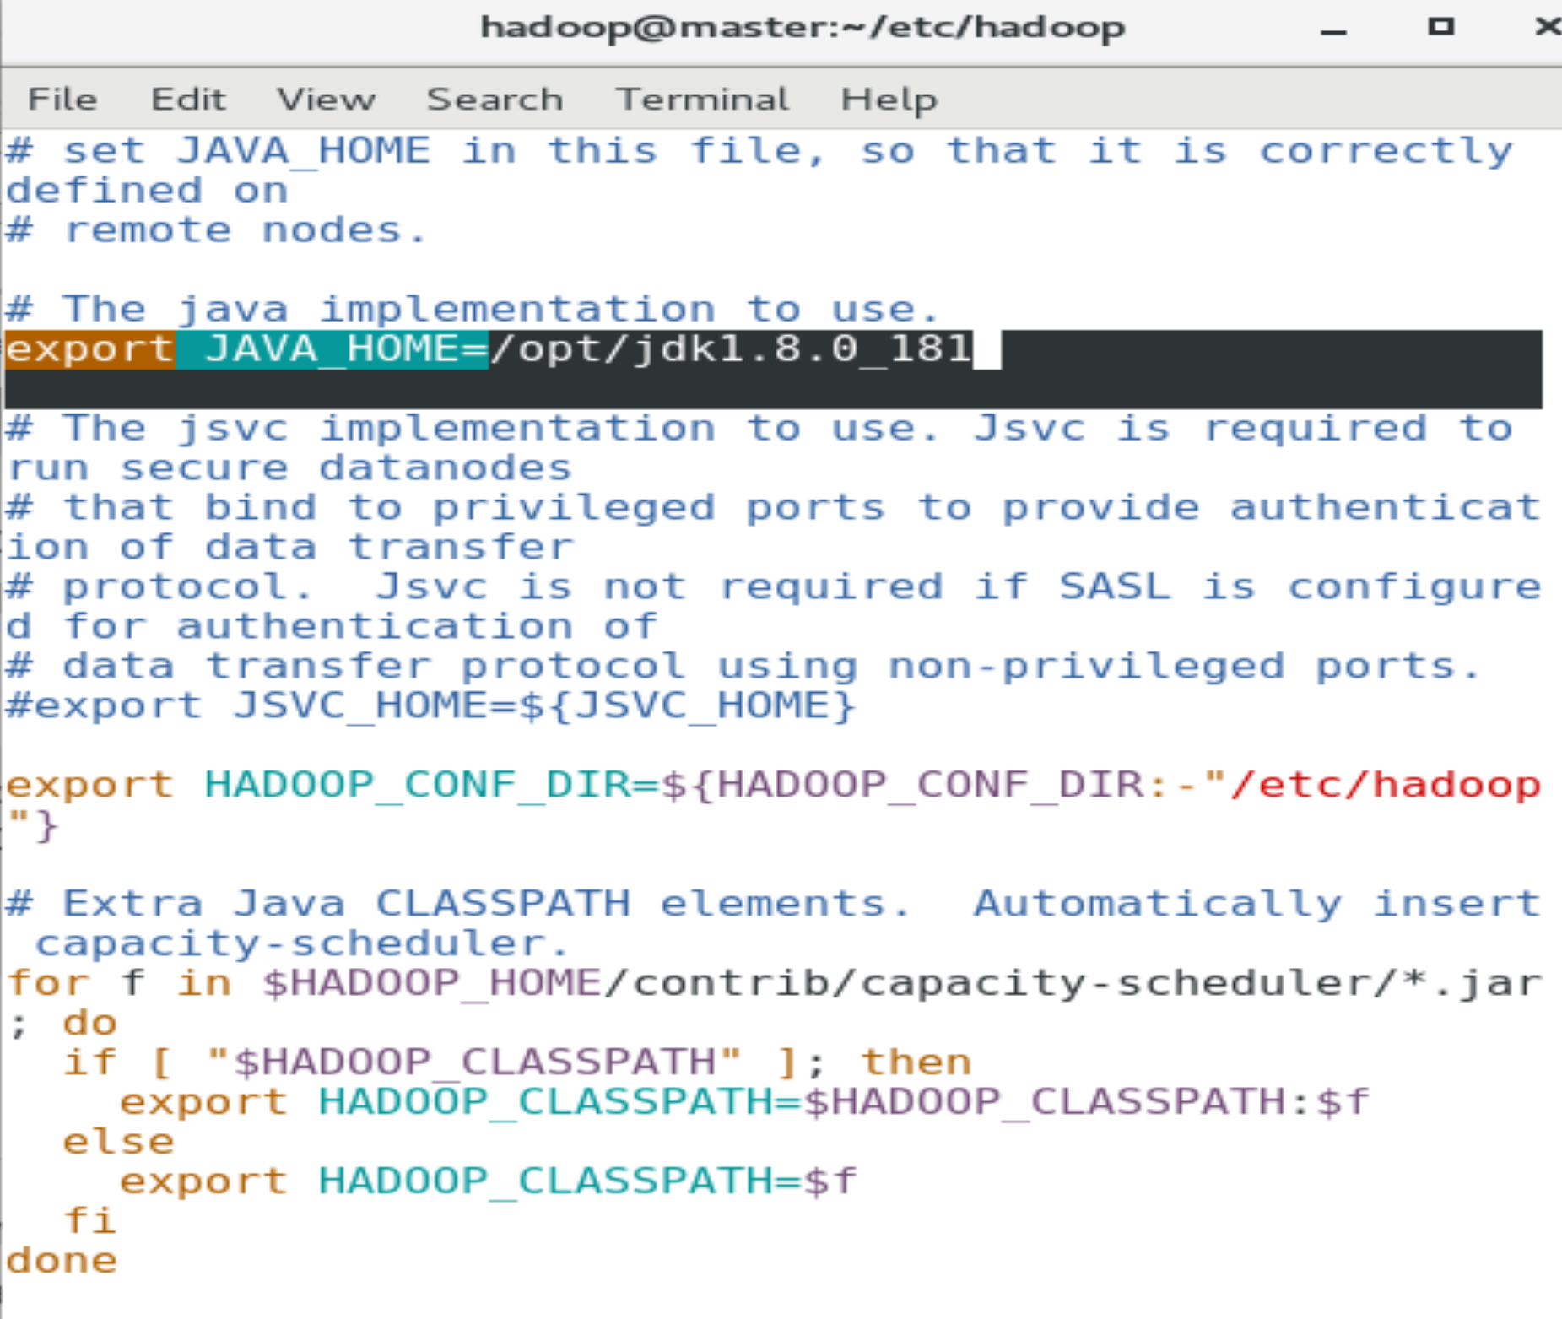

**Step 12:**

Configure Hadoop slaves using “vi etc/Hadoop/slaves”

Change localhost with “master.hadoop.lan” and no spaces.

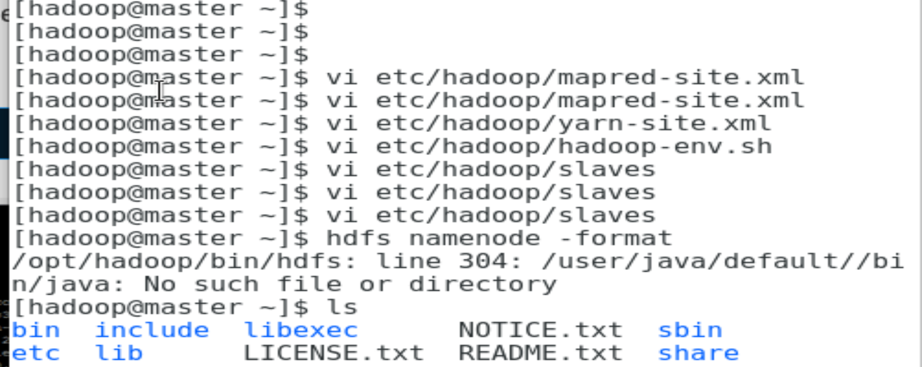

**Step 13:**

Format the Hadoop Namenode using below command line:

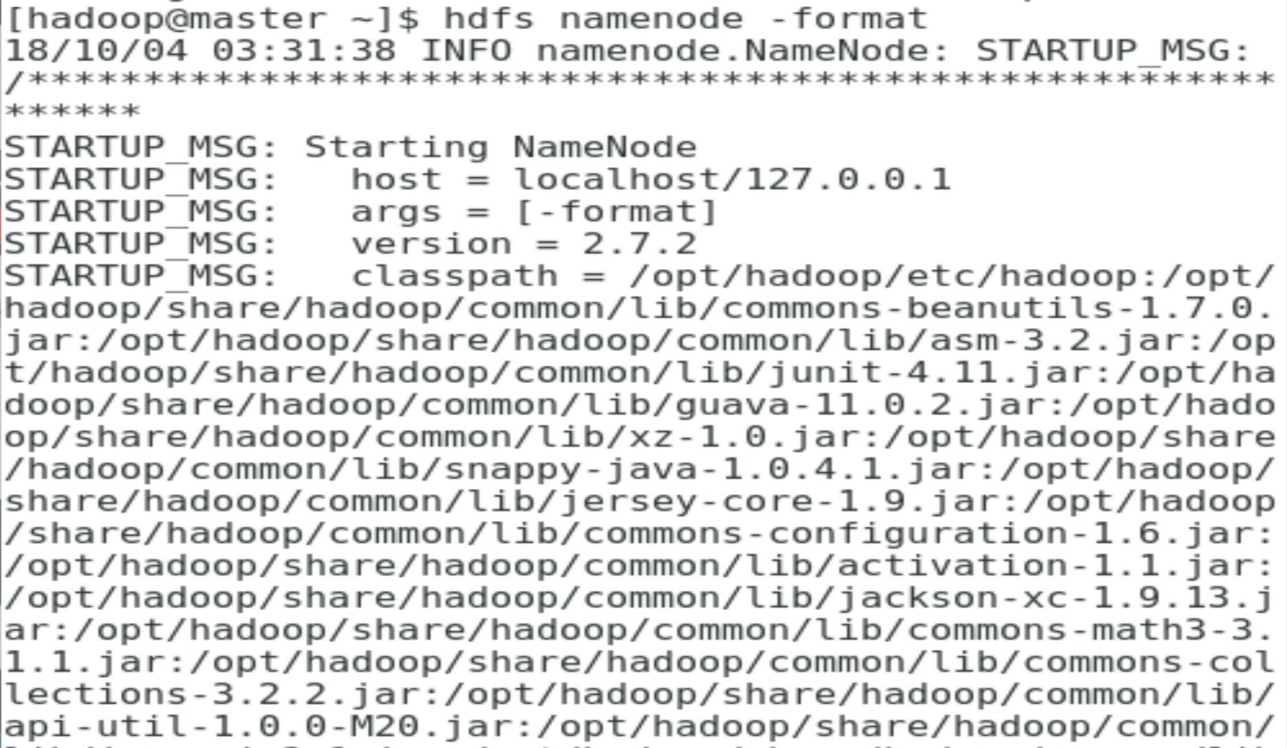

**In the end we get:**

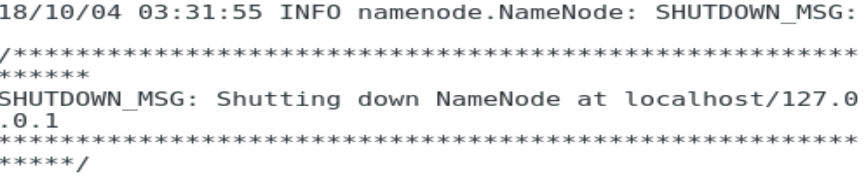

**Step 14:**

Start the DFS and YARN

use “start-dfs.sh” for DFS and “start-yarn.sh” for YARN.

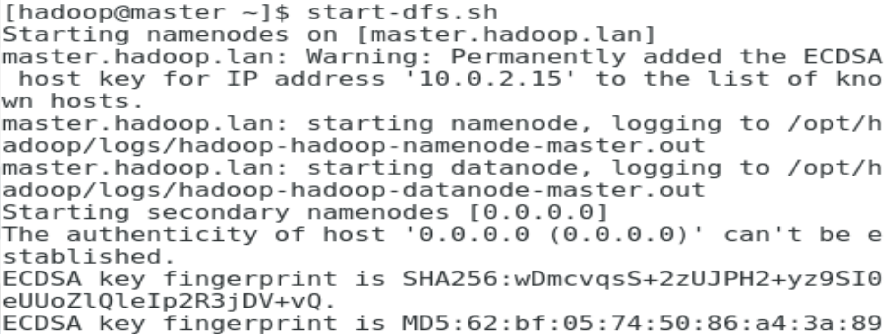

Then Start Yarn:

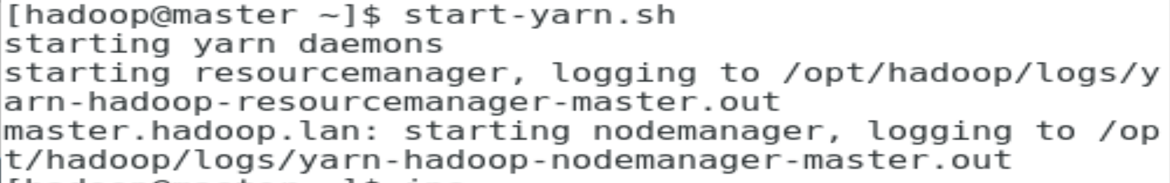

**Step 15:**

Final Check on Hadoop domains Installation:

Check for the Output for domains installed on Hadoop using “jps” :

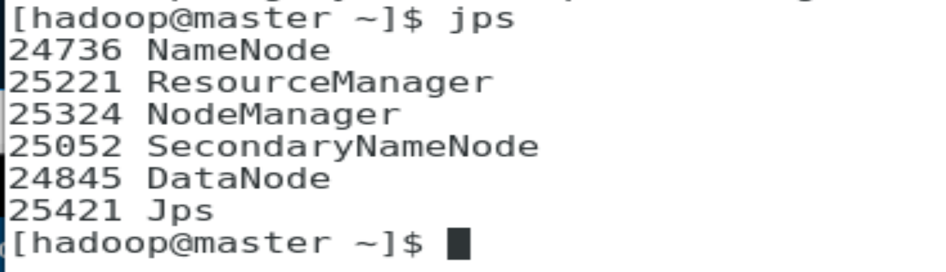

**Step 16:**

Pig Installation:

Download .tar file from the below link:

<http://www-us.apache.org/dist/pig/pig-0.16.0/pig-0.16.0.tar.gz>

use wget to download.

Then extract using “tar -xzf pig-0.16.0.tar.gz”

**Note**: This should be performed on Hadoop user.

**Step 17:**

Edit Pig_Home path and Class_path as given below:

Use “vi .bashrc” to add the below lines, add the following at the end of the file:

**# Set PIG_HOME**

**export PIG_HOME=/home/edureka/pig-0.16.0  
export PATH=$PATH:/home/edureka/pig-0.16.0/bin  
export PIG_CLASSPATH=$HADOOP_CONF_DIR**

**Note**: Make sure that the Hadoop path is also set.

Next to update Pig_Home path use command: “source .bashrc” use the same terminal.

**Note**: Try not to switch terminals while installing and updating any “vi”

Reference: <https://www.edureka.co/blog/apache-pig-installation>

**Step 18:**

**Note**: Namenode is given after “:50070” and Cluster information on “:8088” and 127.0.0.1 is a global ip address. Below link for more information:

<https://stackoverflow.com/questions/24044861/hadoop-namenode-ip-address>

Node Manager information using ip “127.0.0.1:50070/”

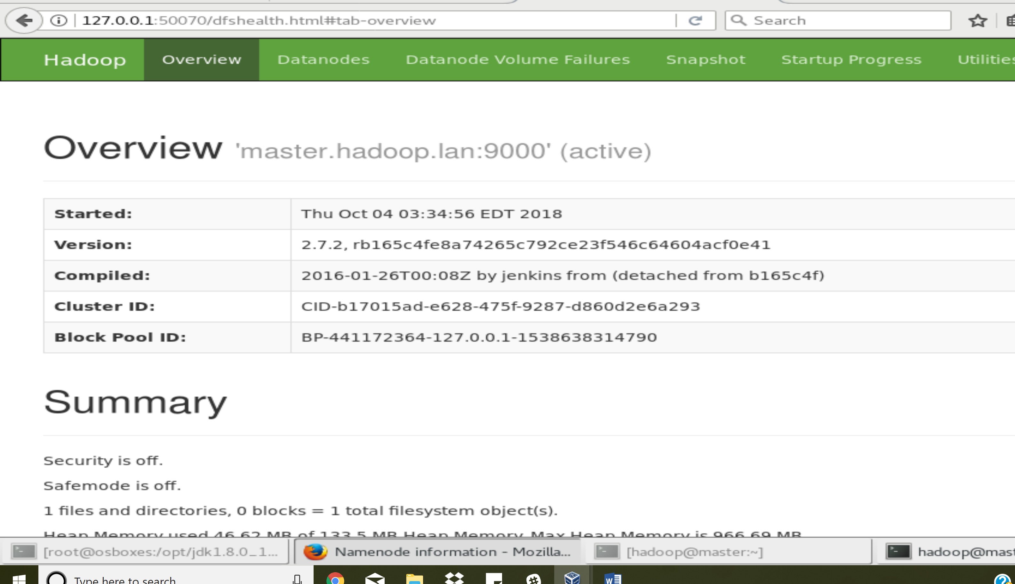

For Cluster and Resource Manager: use IP “127.0.0.1:8088”

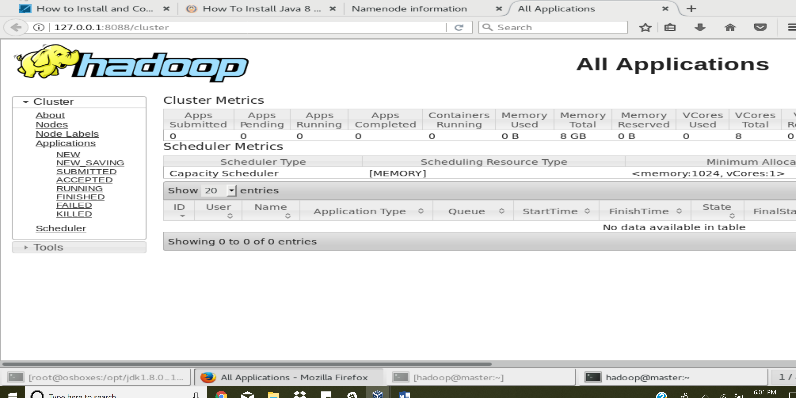

Step 19:

To run pig from HDFS use the following commands:

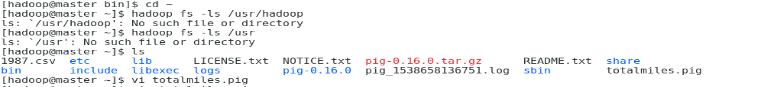

And insert the lines as given below:

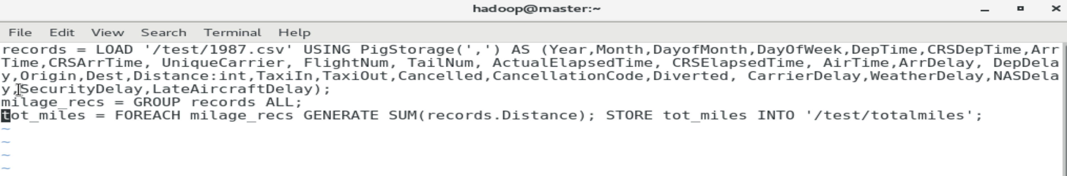

Now run the pig as “pig totalmiles.pig” following is the output:

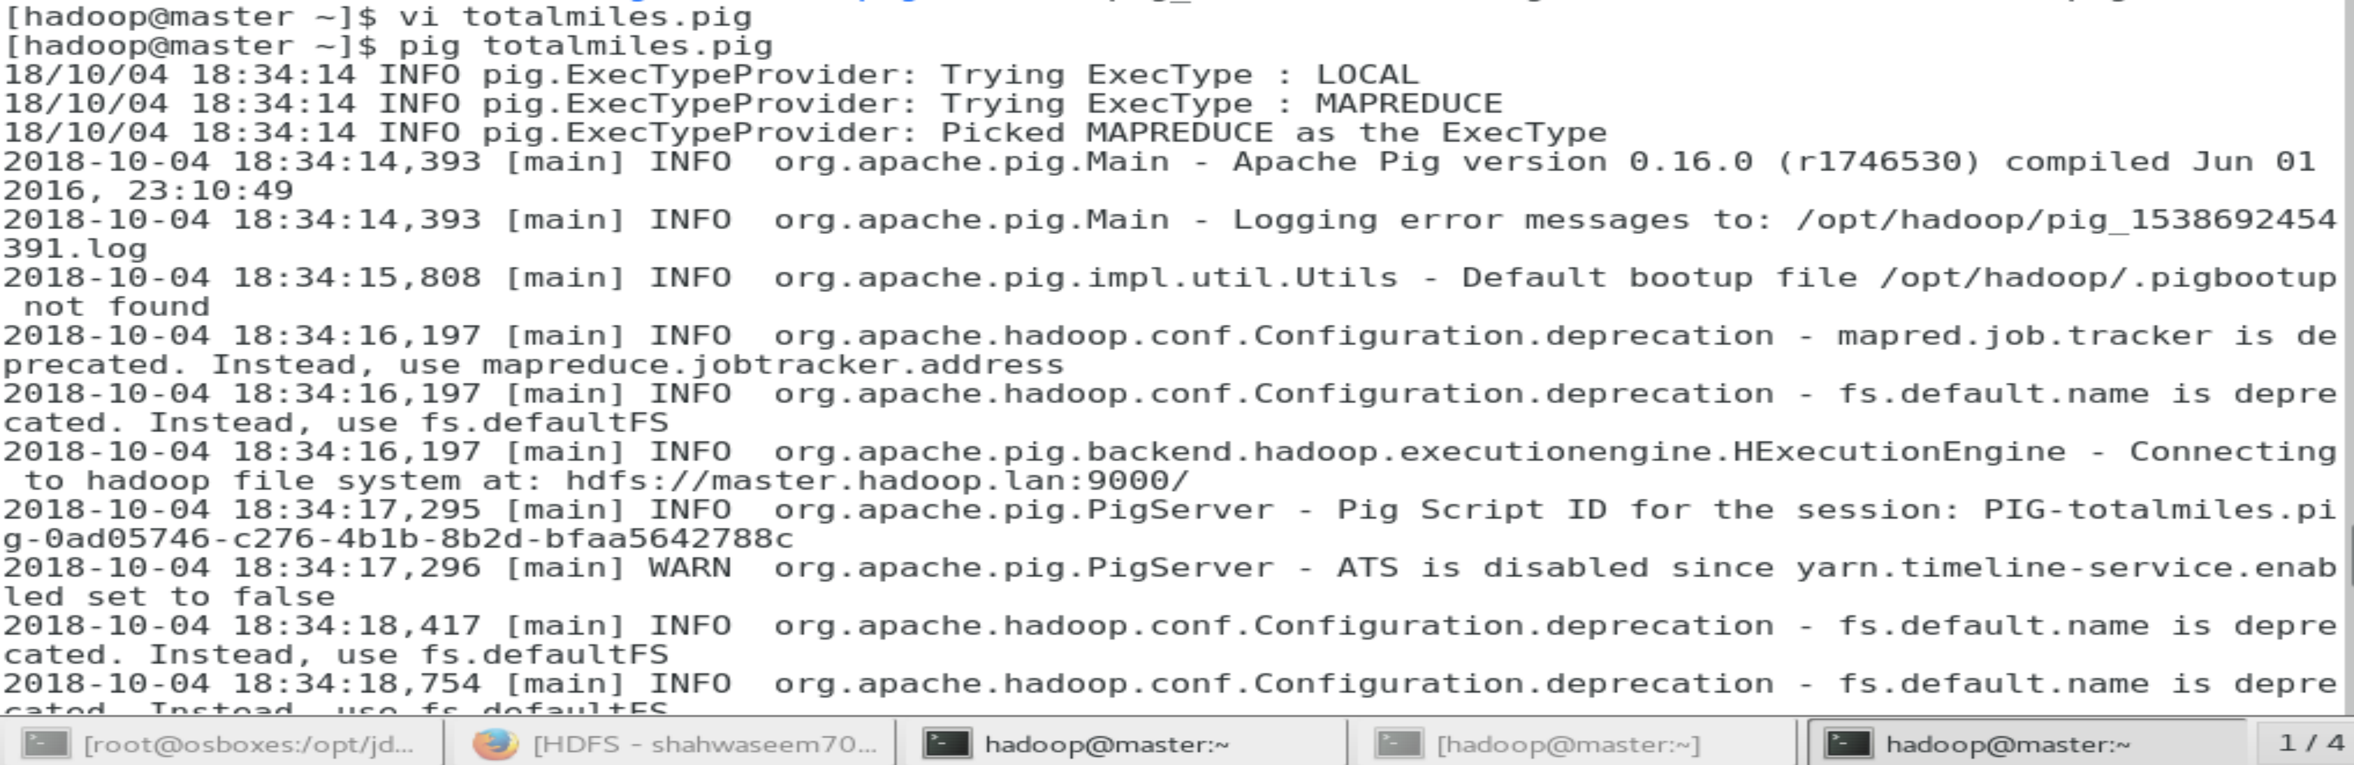

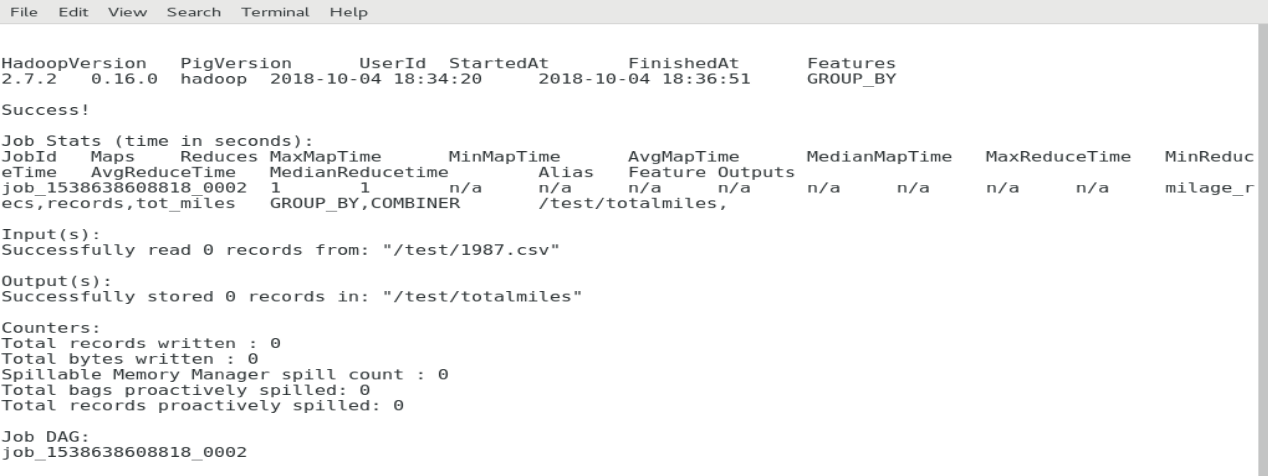

Now check for the file “part-r-00000” in HDFS cluster. If you find it run the following command:

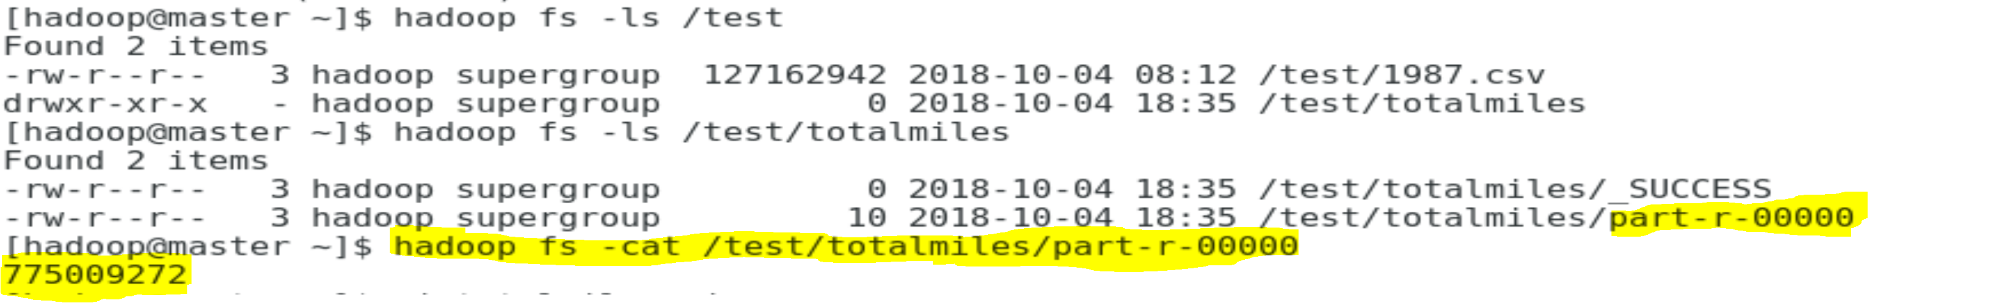

Thanks!

**References:**

[**https://docs.oracle.com/javase/tutorial/essential/environment/paths.html**](https://docs.oracle.com/javase/tutorial/essential/environment/paths.html)

[**https://www.linode.com/docs/databases/hadoop/how-to-install-and-set-up-hadoop-cluster/**](https://www.linode.com/docs/databases/hadoop/how-to-install-and-set-up-hadoop-cluster/)

[**https://stackoverflow.com/questions/24044861/hadoop-namenode-ip-address**](https://stackoverflow.com/questions/24044861/hadoop-namenode-ip-address)

[**https://linuxize.com/post/install-java-on-centos-7/**](https://linuxize.com/post/install-java-on-centos-7/)

[**https://cwiki.apache.org/confluence/display/BIGTOP/How+to+install+Hadoop+distribution+from+Bigtop+0.3.0**](https://cwiki.apache.org/confluence/display/BIGTOP/How+to+install+Hadoop+distribution+from+Bigtop+0.3.0)

[**https://unskilledcoder.github.io/hadoop/2016/12/10/hadoop-cluster-installation-basic-version.html#2**](https://unskilledcoder.github.io/hadoop/2016/12/10/hadoop-cluster-installation-basic-version.html#2)